Figure S1: Risk of bias summary (Red=high risk; yellow=unclear; green=low risk)
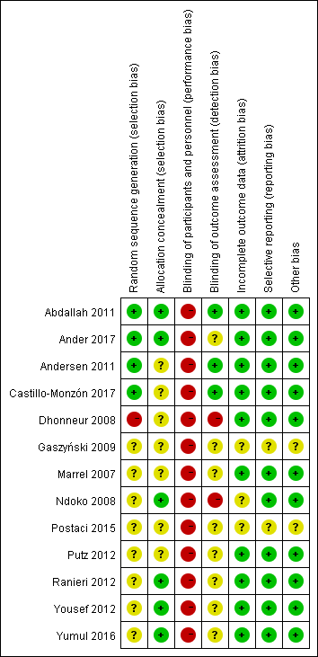

Table S1: The assessment judgment outcomes of RCTs
Domain | Risk of bias arising from the randomization process | Risk of bias due to deviations from the intended interventions (effect of assignment to intervention) | Risk of bias due to deviations from the intended interventions (effect of adhering to intervention) | Missing outcome data | Risk of bias in measurement of the outcome | Risk of bias in selection of the reported result | Overall risk of bias
Abdallah(2011) | Low risk | Low risk | Low risk | Low risk | Low risk | Low risk | Low risk
Ander(2017) | Low risk | Low risk | Low risk | Low risk | Some concerns | Low risk | Low risk
Andersen(2011) | Low risk | Low risk | Low risk | Low risk | Some concerns | Low risk | Low risk
Castillo-Monzón (2017) | Low risk | Some concerns | Low risk | Low risk | Low risk | Low risk | Low risk
Dhonneur(2008) | High risk | Some concerns | Some concerns | Low risk | Low risk | Low risk | Some concerns
Gaszyński(2009) | Some concerns | Some concerns | Some concerns | Some concerns | Some concerns | Some concerns | Some concerns
Marrel(2007) | Some concerns | Low risk | Low risk | Low risk | Low risk | Low risk | Low risk
Ndoko(2008) | Some concerns | Low risk | Low risk | Some concerns | Low risk | Low risk | Some concerns
Postaci(2015) | Some concerns | Some concerns | Some concerns | Some concerns | Some concerns | Some concerns | Some concerns
Putz(2012) | Some concerns | Low risk | Low risk | Low risk | Low risk | Low risk | Low risk
Ranieri(2012) | Some concerns | Low risk | Low risk | Low risk | Low risk | Low risk | Low risk
Yousef(2012) | Some concerns | Low risk | Low risk | Low risk | Low risk | Low risk | Low risk
Yumul(2016) | Some concerns | Low risk | Low risk | Low risk | Low risk | Low risk | Low risk

Figure S2: Funnel plot for the successful intubation rate on the first attempt in the pairwise meta-analysis
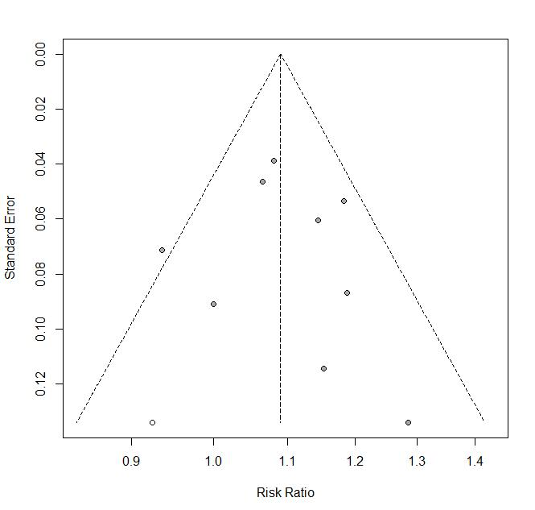

Figure S3: Funnel plot for intubation time in the pairwise meta-analysis
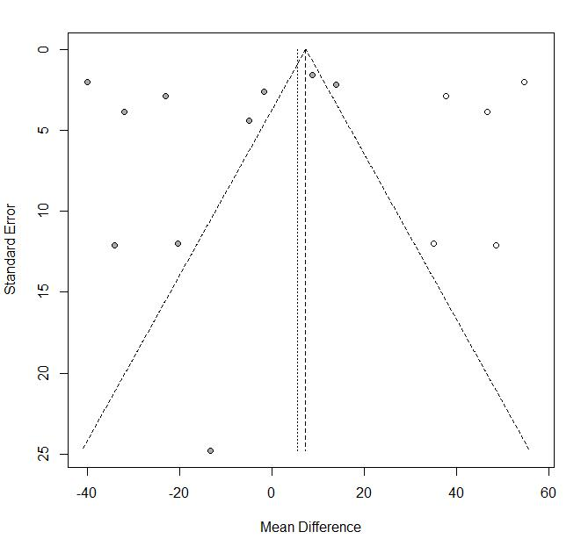

Figure S4: Funnel plot for glottos view in the pairwise meta-analysis
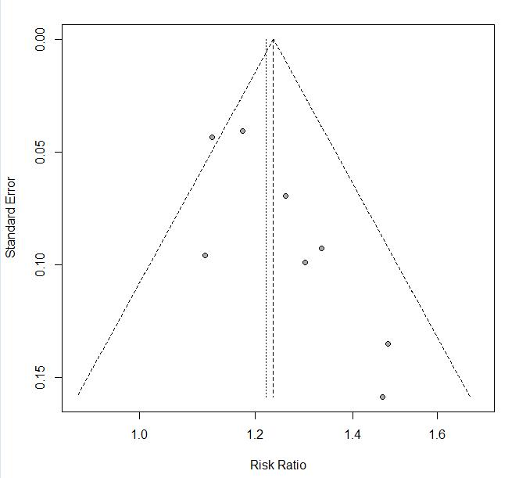

Figure S5: Funnel plot for the composite complications in the pairwise meta-analysis.
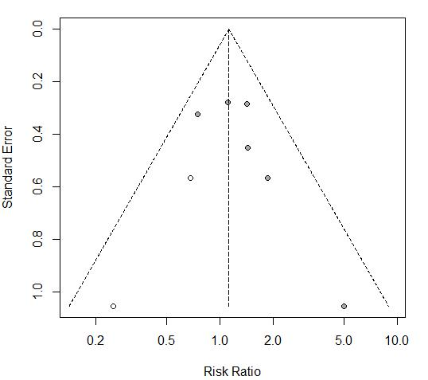

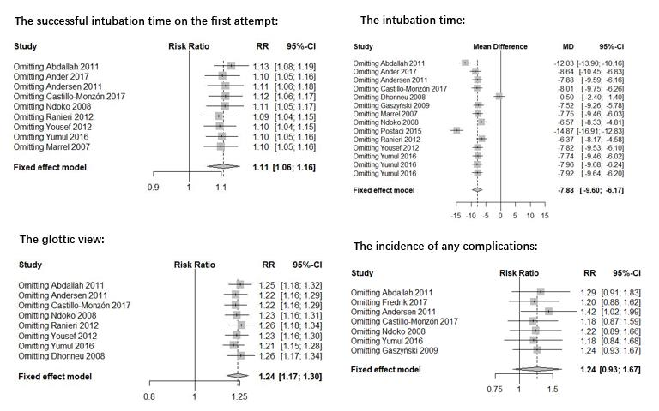
Figure S6: Sensitivity analysis for each outcome in the pairwise meta-analysis.

Figure S7: Trial sequential analysis of intubation time.
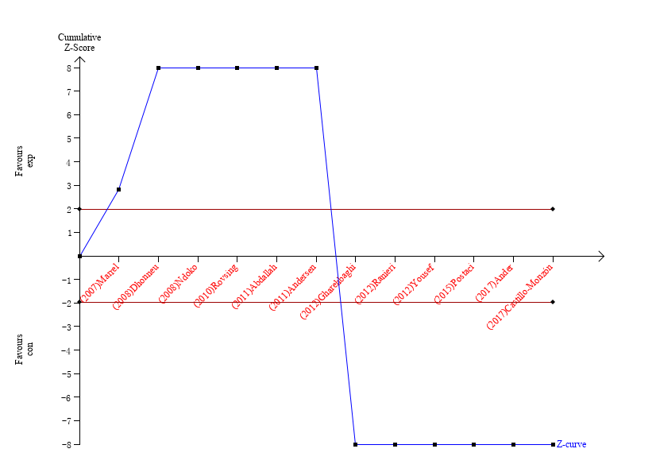
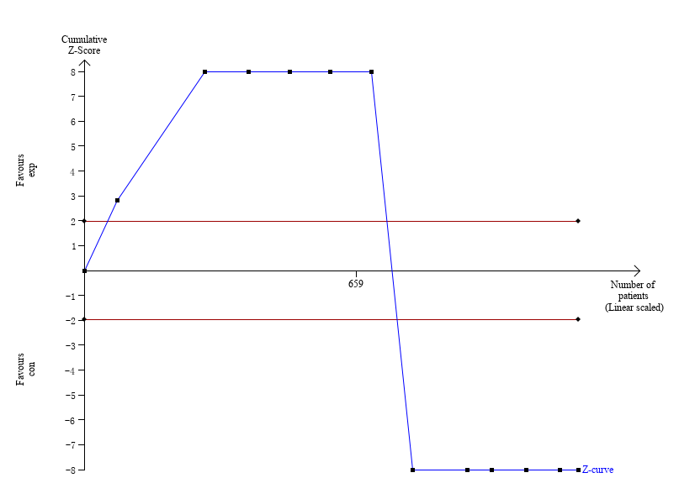

Figure S8: Trial sequential analysis of glottic view.
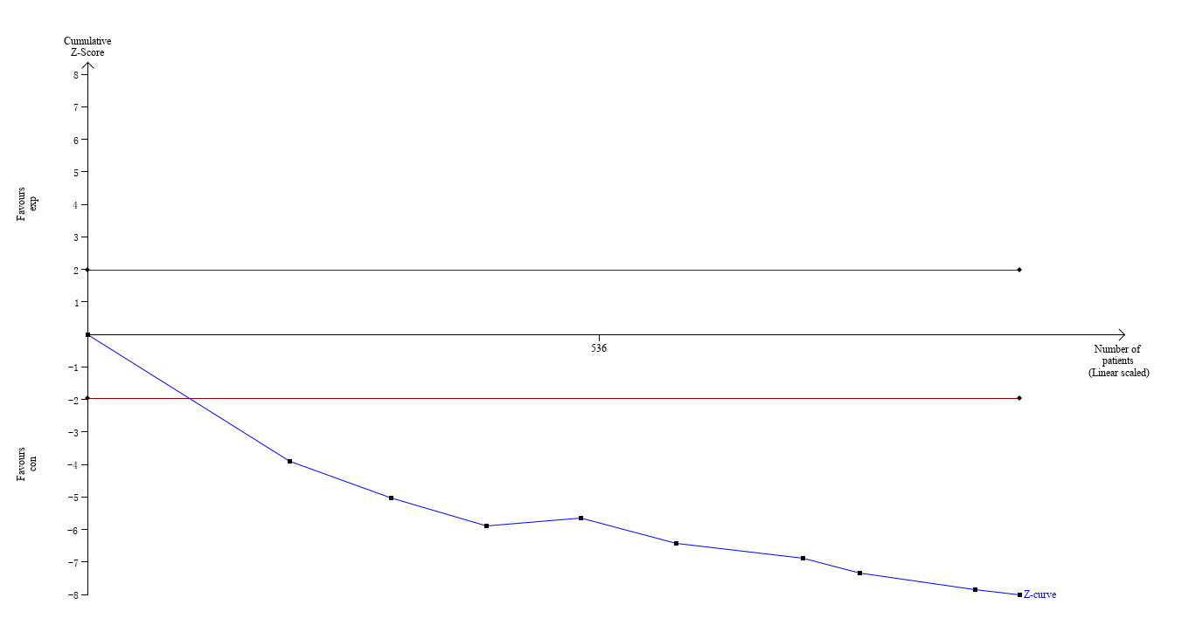
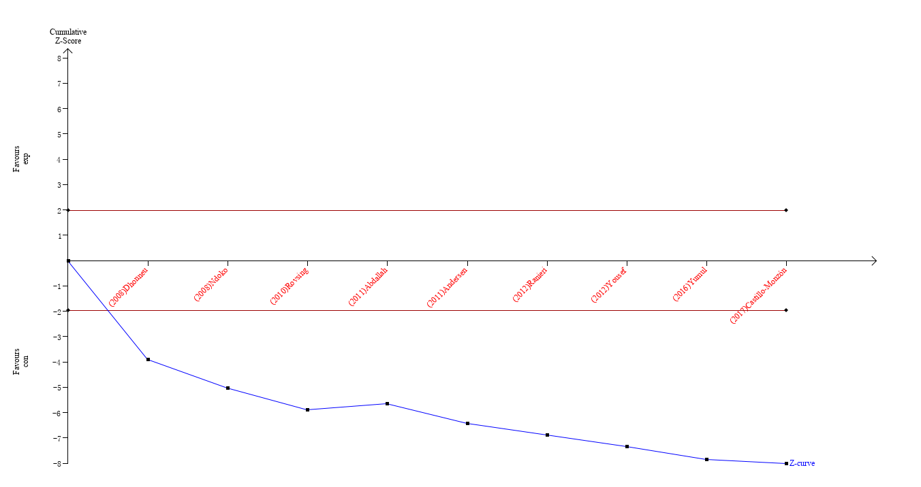

Figure S9: Trial sequential analysis of composite complications.
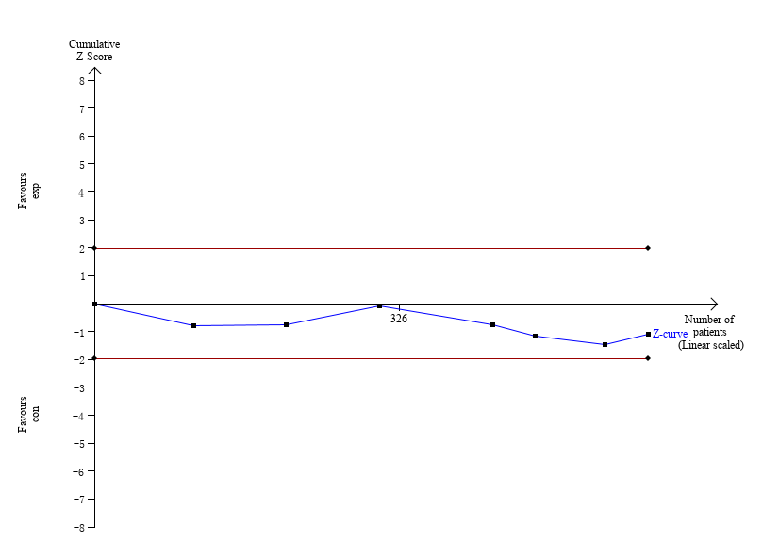
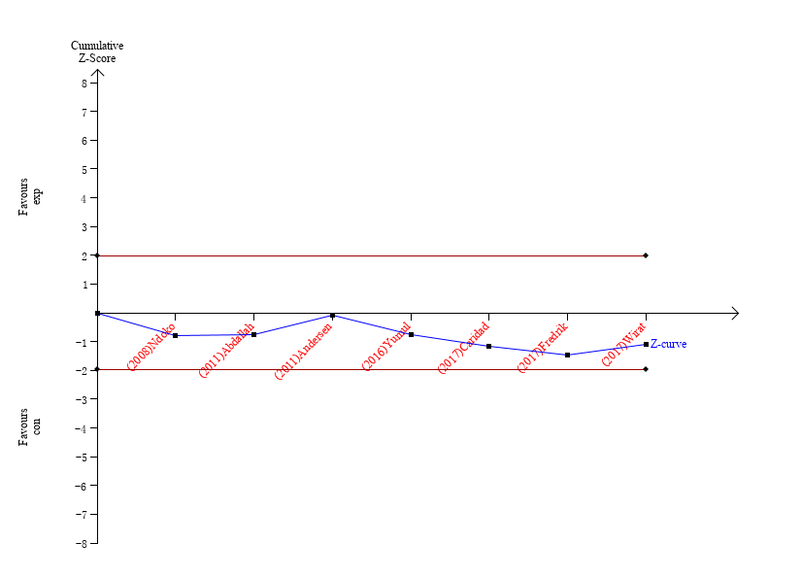

Figure S10: Trial sequential analysis of the successful intubation rate on the first attempt.
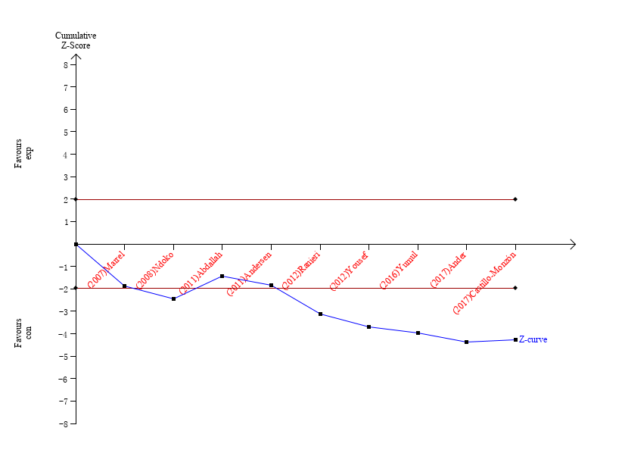
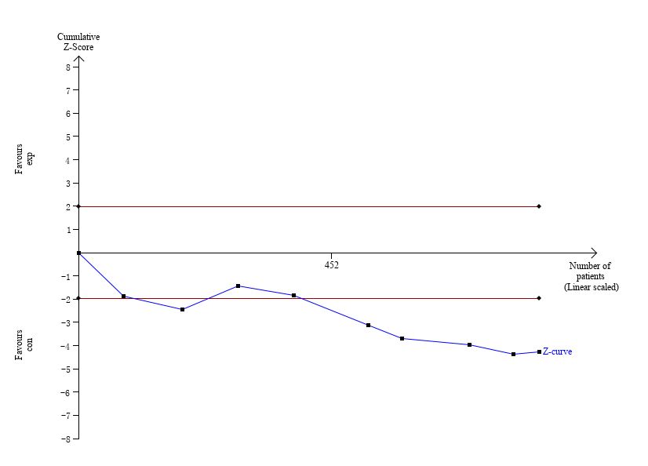

Figure S11: Funnel plot for the successful intubation rate on the first attempt in the network meta-analysis. (A=Macintosh blade video laryngoscopes, B=angulated blade video laryngoscopes, C=side-channel blade video laryngoscopes, D=conventional Macintosh direct laryngoscopes).

Figure S12: Funnel plot for intubation time in the network meta-analysis. (A=Macintosh blade video laryngoscopes, B=angulated blade video laryngoscopes, C=side-channel blade video laryngoscopes, D=conventional Macintosh direct laryngoscopes).

Figure S13: Funnel plot for glottos view in the network meta-analysis. (A=Macintosh blade video laryngoscopes, B=angulated blade video laryngoscopes, C=side-channel blade video laryngoscopes, D=conventional Macintosh direct laryngoscopes).

Figure S14: Funnel plot for composite complications in the network meta-analysis. (A=Macintosh blade video laryngoscopes, B=angulated blade video laryngoscopes, C=side-channel blade video laryngoscopes, D=conventional Macintosh direct laryngoscopes).

Figure S15: Presentation of the network structure of the successful intubation rate on the first attempt. (A=Macintosh blade video laryngoscopes, B=angulated blade video laryngoscopes, C=side-channel blade video laryngoscopes, D=conventional Macintosh direct laryngoscopes).
A
B
C
D

Table S2: Probability ranking of the successful intubation rate on the first attempt. (A=Macintosh blade video laryngoscopes, B=angulated blade video laryngoscopes, C=side-channel blade video laryngoscopes, D=conventional Macintosh direct laryngoscopes).

 | [,1] | [,2] | [,3] | [,4]
A | 0.766055 | 0.185770 | 0.042365 | 0.005810
B | 0.201585 | 0.614210 | 0.151050 | 0.033155
C | 0.031830 | 0.186625 | 0.690510 | 0.091035
D | 0.000530 | 0.013395 | 0.116075 | 0.870000

Figure S16: Presentation of the network structure of intubation time. (A=Macintosh blade video laryngoscopes, B=angulated blade video laryngoscopes, C=side-channel blade video laryngoscopes, D=conventional Macintosh direct laryngoscopes).
A
B
C
D

Table S3: Probability ranking of intubation time. (A=Macintosh blade video laryngoscopes, B=angulated blade video laryngoscopes, C=side-channel blade video laryngoscopes, D=conventional Macintosh direct laryngoscopes).
 | [,1] | [,2] | [,3] | [,4]
A | 0.163320 | 0.286685 | 0.239145 | 0.310850
B | 0.075955 | 0.170250 | 0.280440 | 0.473355
C | 0.036600 | 0.302470 | 0.448115 | 0.212815
D | 0.724125 | 0.240595 | 0.032300 | 0.002980

Figure S17: Presentation of the network structure of glottic view. (A=Macintosh blade video laryngoscopes, B=angulated blade video laryngoscopes, C=side-channel blade video laryngoscopes, D=conventional Macintosh direct laryngoscopes).
A
B
C
D

Table S4: Probability ranking of glottic view. (A=Macintosh blade video laryngoscopes, B=angulated blade video laryngoscopes, C=side-channel blade video laryngoscopes, D=conventional Macintosh direct laryngoscopes).
 | [,1] | [,2] | [,3] | [,4]
A | 0.799805 | 0.241990 | 0.046685 | 0.00152
B | 0.274630 | 0.690310 | 0.034940 | 0.00012
C | 0.015565 | 0.067615 | 0.916300 | 0.00052
D | 0.000000 | 0.000085 | 0.002075 | 0.99784

Figure S18: Presentation of the network structure of composite complications. (A=Macintosh blade video laryngoscopes, B=angulated blade video laryngoscopes, C=side-channel blade video laryngoscopes, D=conventional Macintosh direct laryngoscopes).
A
B
C
D

Table S5: Probability ranking of composite complications. (A=Macintosh blade video laryngoscopes, B=angulated blade video laryngoscopes, C=side-channel blade video laryngoscopes, D=conventional Macintosh direct laryngoscopes).

 | [,1] | [,2] | [,3] | [,4]
A | 0.16609 | 0.451095 | 0.339795 | 0.043020
B | 0.00050 | 0.005925 | 0.057570 | 0.936005
C | 0.80897 | 0.140595 | 0.044660 | 0.005775
D | 0.02444 | 0.402385 | 0.557975 | 0.015200

Figure S19: The test of inconsistency accessed by the node splitting method in the successful intubation rate on the first attempt in network meta-analysis. (A= Macintosh blade video laryngoscopes, B= angulated blade video laryngoscopes, C=side-channel blade video laryngoscopes, D=conventional Macintosh direct laryngoscopes).
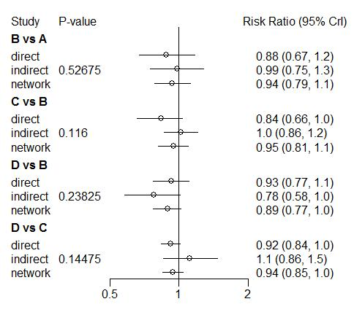

Figure S20: The test of inconsistency accessed by the node splitting method in intubation time in network meta-analysis. (A= Macintosh blade video laryngoscopes, B= angulated blade video laryngoscopes, C=side-channel blade video laryngoscopes, D=conventional Macintosh direct laryngoscopes).
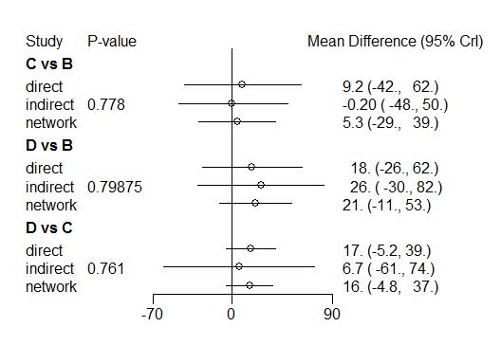

Figure S21: The test of inconsistency accessed by the node splitting method in glottis view in network meta-analysis. (A=Macintosh blade video laryngoscopes, B=angulated blade video laryngoscopes, C=side-channel blade video laryngoscopes, D=conventional Macintosh direct laryngoscopes).
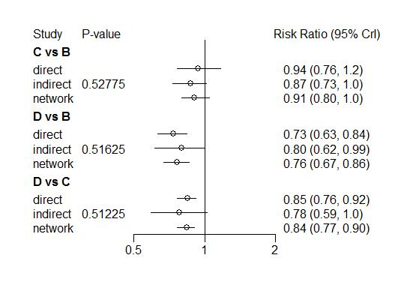

Figure S22: The test of inconsistency accessed by the node splitting method in the incidence of any complications in network meta-analysis. (A= Macintosh blade video laryngoscopes, B= angulated blade video laryngoscopes, C=side-channel blade video laryngoscopes, D=conventional Macintosh direct laryngoscopes).
